Healthcare Metrics Project
Step 3: Data Engineering Pipeline Architecture
Project | Healthcare Metrics Project
Document | Step 3 - Data Engineering Pipeline / Architecture - Solution Design Document
Author | Polat
Date | 2026-09-19
Version | 1.2 - Streamlit hosting resolved per SME; DynamoDB cursor still open
Status | Awaiting final SME sign-off on remaining open item (see Section 9)

Revision note (v1.1): Per SME feedback, this is a batch pipeline with no real-time requirement, so the design has been consolidated onto AWS Glue end to end. AWS Lambda, Amazon EventBridge, and AWS Step Functions have been removed; ingestion now runs as a Glue Python Shell job, transformation is split into Glue Spark jobs across Bronze/Silver/Gold zones (medallion naming, replacing Raw/Curated/Presentation), and AWS Glue Workflow handles both scheduling and step sequencing. Amazon QuickSight has been replaced with a Streamlit dashboard. Two open questions from this revision were called out in Section 9 for the SME's input.
Revision note (v1.2): The SME has since directed the Streamlit hosting approach - Streamlit Community Cloud (free), built and tested locally against AWS, then deployed by pushing the code to GitHub. That open question is now resolved and documented in Section 9 as a deliberate, SME-approved exception to the Section 2 AWS-only constraint for the visualization layer only. The DynamoDB-vs-S3-state-file question for the sync cursor remains open. No implementation has occurred - this project remains in the design phase pending final sign-off.

1. Purpose
This document defines the proposed AWS data pipeline architecture for the Healthcare Metrics Project: ingesting CMS PBJ nurse staffing data and the associated Nursing Home Compare supporting files from Google Drive, transforming them into trustworthy, joined metrics, and serving them through a dashboard. It is submitted for Subject Matter Expert (SME) review and written approval before implementation begins, per the project's Step 3 requirement.

2. Scope & Constraints
- Source: Google Drive, containing the PBJ master CSV and 19 CMS Nursing Home Compare supporting files (profiled in Steps 1-2 of this project).
- Ingestion must be incremental - only new or changed files should be re-processed on each run, not a full re-scan of the Drive folder.
- Constraint: AWS services only. No third-party platforms (e.g. Databricks) - this is a deliberate constraint distinct from other portfolio work, which uses Databricks/Unity Catalog. Every data-processing and storage service in this design is AWS; the one confirmed exception is the Streamlit visualization layer, which is hosted on Streamlit Community Cloud per SME direction (Section 9) - a deliberate, approved carve-out for presentation only, not for data or compute.
- This is a batch pipeline, not a real-time one - Google Drive is checked periodically rather than reacting to changes instantly. Per SME feedback, the design should minimize the number of distinct services rather than optimize for the cheapest possible single job execution.
- Deliverables: this document, an accompanying editable diagram (healthcare_pipeline_architecture.drawio), and written SME sign-off (Section 9) before implementation proceeds.

3. Why There Is No Native AWS-to-Google-Drive Connector
Amazon AppFlow supports Google Sheets and Google Analytics as sources, but not Google Drive. AWS Transfer Family provides managed SFTP/FTPS/FTP endpoints, which Google Drive does not expose. As a result, the standard and correct pattern - used throughout this design - is custom code that calls the Google Drive API directly, rather than relying on a managed AWS connector that does not exist for this source. That code runs as an AWS Glue Python Shell job (v1.1), consistent with keeping ingestion and transformation on the same service family per SME feedback.

4. Architecture Overview
The diagram below shows the high-level flow. The finalized, editable version with every supporting component (Secrets Manager, DynamoDB, Glue Catalog, Glue Workflow, IAM/KMS/CloudWatch/SNS) is Healthcare_Metrics_Project_Final.drawio, editable directly in diagrams.net. A written walkthrough (Healthcare_Metrics_Pipeline_Diagram_Explanation.docx) explains every component and connection on it in detail.
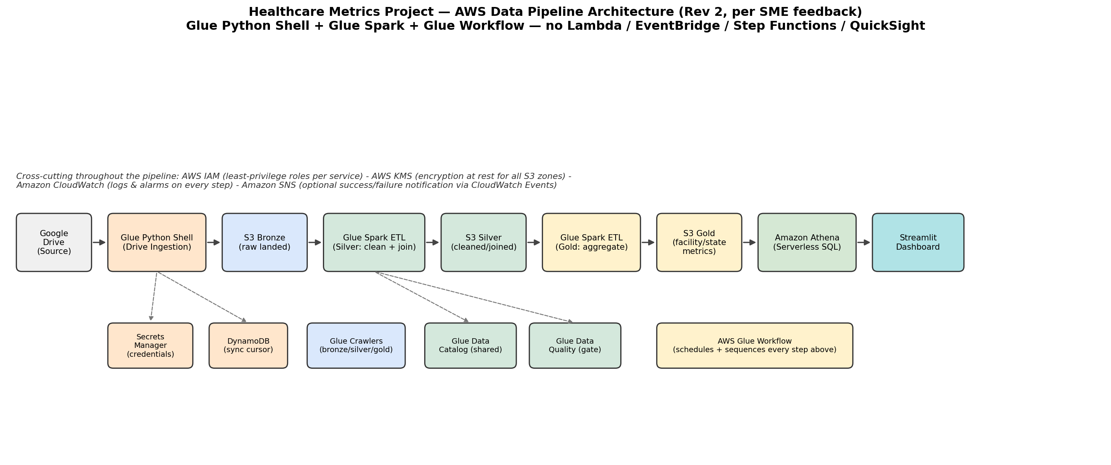

5. Component Breakdown
Layer | AWS Service | Role in the Pipeline
Ingestion | AWS Glue Python Shell Job | Calls the Google Drive API's Changes API to pull only new/modified files since the last run; writes them to S3 Bronze. Replaces the Lambda function from v1.0 - same logic, running inside Glue so ingestion and transformation share one service family, per SME feedback.
Ingestion | AWS Secrets Manager | Stores the Google service-account / OAuth credentials the Python Shell job needs to call the Drive API. Never hard-coded in code.
Ingestion | Amazon DynamoDB | Stores the Drive "page token" (sync cursor) between runs, so ingestion is truly incremental rather than re-scanning the whole Drive every time. (Open question for SME in Section 9: keep DynamoDB, or store this single value as a small state file in S3 instead?)
Storage | Amazon S3 | The data lake itself, using medallion naming per SME preference: Bronze zone (as-landed files), Silver zone (cleaned/joined Parquet), Gold zone (aggregated facility_metrics / state_summary tables).
Cataloging | AWS Glue Data Catalog | Central, shared metadata store of table schemas - used by the Glue Spark jobs and Athena alike.
Cataloging | AWS Glue Crawler | Scans S3 Bronze, Silver, and Gold zones, infers schema automatically, and registers/updates tables in the Data Catalog.
Transform | AWS Glue Spark ETL Job (Silver) | Applies the fixes and joins from Steps 1-3 of this project: cp1252 encoding, PROVNUM/CCN as string, per-column outlier thresholds, non-reporting facility flag, and the join across PBJ + NH_ProviderInfo + NH_QualityMsr_Claims. Reads Bronze, writes Silver.
Transform | AWS Glue Spark ETL Job (Gold) | Aggregates the cleaned Silver data into the facility- and state-level metric tables used by the dashboard. Reads Silver, writes Gold.
Transform | AWS Glue Data Quality | Runs automated validation rules (row counts, null checks, schema conformance) against the cataloged Bronze table before the Silver job runs.
Orchestration | AWS Glue Workflow | Replaces EventBridge + Step Functions from v1.0. A scheduled trigger starts the run; conditional triggers chain each subsequent step on the previous one's success: ingest -> crawl Bronze -> validate -> transform (Silver) -> crawl Silver -> aggregate (Gold) -> crawl Gold.
Serving | Amazon Athena | Serverless SQL query engine over the S3 Silver/Gold zones and Glue Catalog - no servers to manage, pay per query scanned.
Visualization | Streamlit Dashboard | Replaces Amazon QuickSight from v1.0, per SME feedback - queries Athena and renders the nurse-to-patient ratio, occupancy, and readmission-correlation views at no per-seat licensing cost. Hosting resolved per SME direction: Streamlit Community Cloud (free) - see Section 9.
Security | AWS IAM | Least-privilege execution roles scoped per service (Glue Python Shell, Glue Spark, Glue Workflow) - no service has broader access than it needs.
Security | AWS KMS | Encrypts data at rest across all three S3 zones.
Monitoring | Amazon CloudWatch | Centralized logs and metrics for every Glue job and crawler run; alarms on failure or unusual duration.
Monitoring | Amazon SNS | Optional: a CloudWatch Events rule on the Glue Workflow's completion state can publish a success/failure notification (e.g. email) at the end of each run.

6. Incremental Ingestion Strategy
Rather than re-listing every file in the Drive folder on each run (slow, and wasteful of API quota), the Glue Python Shell job uses the Google Drive Changes API:
- On first run, it calls Drive's changes.getStartPageToken and stores the returned token in DynamoDB.
- On every subsequent run, it calls changes.list with that stored token, which returns only files added, modified, or removed since the last run.
- New/changed files are downloaded and written to the S3 Bronze zone under a date-partitioned prefix (e.g. bronze/pbj/ingest_date=2026-09-18/).
- The new page token returned by that call is written back to DynamoDB, ready for the next run.
This means a scheduled run with zero changes on the Drive costs almost nothing (one lightweight API call), and a run with new data only processes what actually changed - true incremental ingestion rather than a full re-sync. This logic is unchanged from v1.0; only the compute running it (Glue Python Shell instead of Lambda) has changed.

7. Data Quality & Validation
The validation rules encoded in the Glue Data Quality step are carried over directly from the manual analysis already done in Steps 1-2 of this project, so the pipeline enforces automatically what was previously checked by hand:
- File encoding: all CMS source files are Windows-1252 (cp1252), not UTF-8 - enforced at read time.
- Key formatting: PROVNUM / CMS Certification Number is read and stored as a fixed-length string, never as an integer, to preserve leading zeros.
- Per-column outlier thresholds on daily hours (RN > 500, LPN > 1000, CNA > 2000) - set from each column's actual distribution, not one blanket number across roles with very different natural scales.
- Facilities with implausibly low total nurse hours relative to their patient census (below the 0.5th percentile) are flagged as likely non-reporting rather than treated as real "zero staffing" data points.
- Row/column counts and schema are checked against the cataloged Bronze table's expected shape before data is promoted to Silver - a failure here halts the Glue Workflow rather than silently loading bad data.

8. Security & Cost Notes
- All Google API credentials live in Secrets Manager, never in code or environment variables in plain text.
- Every IAM role is scoped to only the actions/resources that specific service needs (e.g. the Glue Python Shell role can write to the Bronze S3 prefix only, not the whole bucket).
- All three S3 zones use KMS encryption at rest.
- Consolidating onto Glue removes several always-on billing considerations from v1.0: no Lambda invocation cost, no EventBridge schedule, no Step Functions state transitions. Combined with replacing QuickSight (roughly $24/month per Author seat) with a self-hosted Streamlit dashboard, this revision is meaningfully cheaper to run continuously, not just simpler to operate.
- Every remaining component is pay-per-use/serverless (Glue, Athena) with no idle infrastructure cost, aside from whatever compute hosts Streamlit - appropriate for a project at this data volume (single-digit GB per quarter).

9. Assumptions & Open Questions for SME
- Assumes a Google Cloud service account with read access to the shared Drive folder is available and can be created for this project.

9.1 Resolved this revision
Resolved - Streamlit hosting (per SME direction, Sept 2026): use Streamlit Community Cloud, since it's free. Build and test the dashboard locally (e.g. in VS Code, using aws configure to connect to AWS), then push the code to GitHub and deploy from there on Streamlit Community Cloud; attach dashboard screenshots to the GitHub repo as well. This is treated as a deliberate, SME-approved exception to the Section 2 AWS-only constraint - it applies only to where the visualization layer is hosted, not to any data storage, processing, or orchestration component, all of which remain AWS-only.

9.2 Still open
- Open question: with ingestion now inside a Glue Python Shell job that already reads/writes S3 directly, is a dedicated DynamoDB table still the right home for the single sync-cursor value, or would a small state file stored in S3 be a simpler equivalent, in the same spirit as removing Lambda/EventBridge/Step Functions?
- Redshift is noted as a future upgrade path if query performance on Athena becomes a bottleneck at larger data volumes - not included in this initial design to keep cost and complexity minimal.
- CI/CD for deploying the Glue code (e.g. via CodePipeline) is out of scope for this document and can be addressed in a follow-up design.

10. SME Review & Approval
This design is submitted for review. Implementation should not begin until this section is signed.
Reviewer (SME) Name
Decision | [ ] Approved [ ] Approved with changes [ ] Rejected
Comments
Signature / Date

